Name: _____________________

**Mathematics Essentials – Unit 1: Test 3**

Mark: ­­­­_____ / 47

|  |
| --- |
| **Multiple Choice Section Marks 5** |

1. Kate’s hourly rate of pay is $9.50 for the first 36 hours and time-and-a-half for every extra hour. How much is she paid for 41 hours?

**A** $389.50 **B** $413.25 **C** $460.75 **D** $584.25

1. Dale has a salary of $48 984 p.a. His fortnightly pay is:

**A** $1884 **B** $1959.36 **C** $2041 **D** $2226.55

1. Hannah receives a commission of 6.5% on all her sales. How much commission does Hannah earn in a week in which her sales total $2800?

**A** $182 **B** $232.14 **C** $430.77 **D** $1820

1. Caleb receives a royalty of 15% on the market price on sales of a book he has written. If the book sells for $12.95, find Caleb’s total royalties for a period when 2180 books have been sold.

**A** $1882.07 **B** $2525.10 **C** $2823.10 **D** $4234.65

1. Morgan’s local council sent a bill for water rates. It showed the following information:

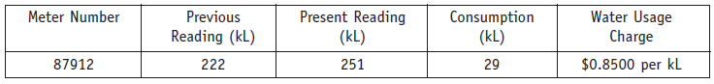

The amount Morgan will need to pay is:

**A** $24.65 **B** $188.70 **C** $213.35 **D** $246.50

|  |
| --- |
| **Question 1 Marks 4** |

Calculate the **area** of the following shapes:

|  |  |  |
| --- | --- | --- |
|  |  | 1. Find the area of the shaded section |

|  |
| --- |
| **Question 2 Marks 5** |

1. Calculate the 2.5% commission earned by a salesman on the following car sales:

|  |  |
| --- | --- |
| 1. Ford Falcon worth $24,887 | 1. Toyota Hilux worth $56,390 |

1. Aaron is paid a salary of $380 per week plus 5% commission on any sales over $40,000 each month. Aaron sold $68,200 worth of goods last month. How much did he earn for the month?

|  |
| --- |
| **Question 3 Marks 2** |

Amanda works on Thursday evening and Saturday at her local supermarket. She is paid $8.40 per hour. This is a casual rate before deductions such as tax. On Thursday she works from 5 pm to 9.30 pm and on Saturday from 12.30 pm to 6 pm.

1. How many hours does Amanda work each week?
2. Calculate her weekly pay at the casual rate.

|  |
| --- |
| **Question 4 Marks 5** |

Justin is 22. He works full-time as a registered plumber. Justin’s basic hourly rate of pay is $18.28.

1. Justin works a 38-hour week. What is his weekly rate of pay?
2. Calculate Justin’s annual salary, assuming 52 weeks in the year.

As well as paying the employee, the employer contributes 9% to the employee’s superannuation.

1. Calculate the employer weekly contribution to Justin’s superannuation. Round the answer to the nearest cent.

Justin’s friend, Matthew, is also a 22 year-old registered plumber. Matthew works as a casual employee. The loading for casual employees is 20% on top of the base rate.

1. What is Matthew’s hourly rate of pay? Round the answer to the nearest cent.

|  |
| --- |
| **Question 5 Marks 7** |

The individual income tax rates for the 2007-2008 financial year are shown in the following table.

**Tax rates 2007 - 2008**

|  |  |
| --- | --- |
| *Taxable income* | *Tax on this income* |
| $1 - $6,000 | Nil |
| $6,001 - $30,000 | 15c for each $1 over $6,000 |
| $30,001- $75,000 | $3,600 plus 30 c for each dollar over $30,000 |
| $75,001- $150,000 | $17,100 plus 40 c for each dollar over $75,000 |
| $150,001and over | $47,100 plus 45 c for each dollar over $150,000 |

Australian Taxation Office

Use the tax table to calculate the amount of tax payable on the following taxable incomes:

|  |  |  |
| --- | --- | --- |
| 1. $25 000 | 1. $37 000 | 1. $150 000 |

|  |
| --- |
| **Question 6 Marks 7** |

Mark’s normal wage is $880.80 for a 40-hour week. He worked overtime and earned $1233.12 in one week.

1. Find his normal hourly rate.
2. How much extra did he get for overtime?
3. How many hours of overtime did he work if he was paid double-time for the overtime worked?

|  |
| --- |
| **Question 7 Marks 2** |

Find the new price of the following items after the discount has been applied:

|  |  |
| --- | --- |
| 1. Original price: $365   Speakers has a 25% discount | 1. Original price: $240     Shoes has a 40% discount |

|  |
| --- |
| **Question 8 Marks 10** |

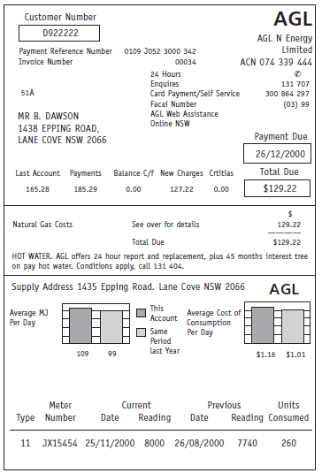Answer the following questions in relation to the gas bill shown.

1. What is the payment reference number?
2. When is the payment due?
3. What is the total amount payable for this bill?
4. What is the difference between the total of this bill and the total of the last bill?
5. What is the meter number?
6. How many units were consumed?
7. If 1 unit = 38.196772 megajoules (MJ), convert the gas units consumed in part **F** to the number of megajoules (MJ). *(Answer to the nearest MJ)*
8. If 1 MJ is charged at the rate of 1.0595 cents, what is the total

cost of the megajoules consumed during this period?

* 1. How much is the supply fee? *(Hint: Total Fee = Supply Fee + New Charges)*